**Experiment No. 9**

**Aim: To solve the two-dimensional boundary-value problem by Finite Difference Method using Matlab**

**Software required: Matlab 7.0**

**Theory:**

In Finite Difference Method, the Partial Differential Equation is converted into a set of linear, simultaneous equations. When the simultaneous equations are written in matrix notation, the majority of the elements of the matrix are zero. Such matrices are called “sparse matrix”. However, for any meaningful problem, the number of simultaneous equations becomes very large, say of the order of a few thousand. There are special purpose routines that deal with very large, sparse matrices. Furthermore, one needs skilful ways of storing such large matrices, otherwise, several Gigabits will be used up just for the storing. An alternative way of solving very large system of simultaneous equations is iterative. The advantage of iterative solution is that the storing of large matrices is unnecessary.

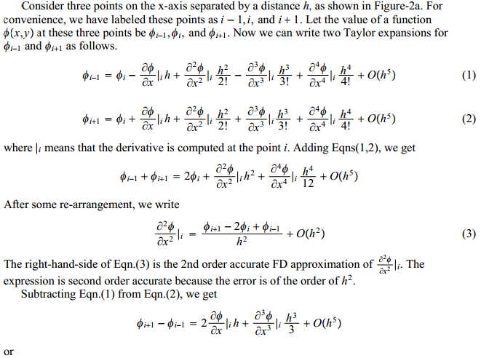

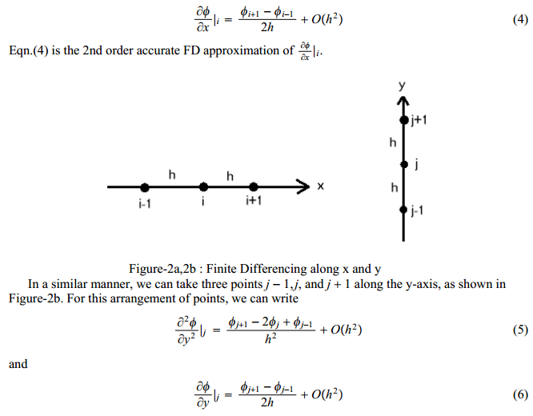

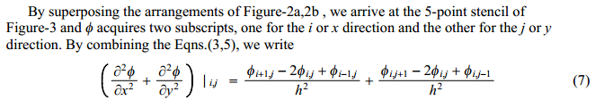

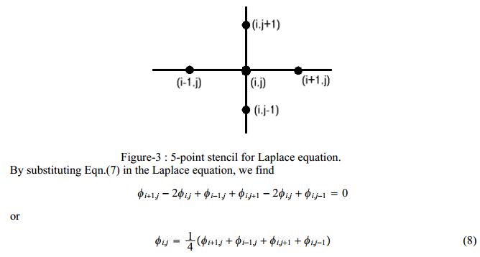

**Result:-**

**Conclusion:-**